**LAB REPORT FOR CHRISTOPHE BOBDA’S GROUP**

**WEEK 2**

Xianhan Li

**INTRODUCTION**

This report includes 2 tasks: The first one is about edges detection and corner detector, I have set up a Canny Edge Detection with Sobel Operator, and used Harris Corner Detector; The second one is about comparing SIFT and SURF, including comparing the computation time, the total number of keypoints found and the percentage of matches.

**TASK1**

STEP1: Gaussian filtering is applied to smooth the image with the aim of removing noise.

Gaussian filter is the discretization of Gaussian function, the corresponding transverse and longitudinal index of the filter into the Gaussian function, so as to obtain the corresponding value.

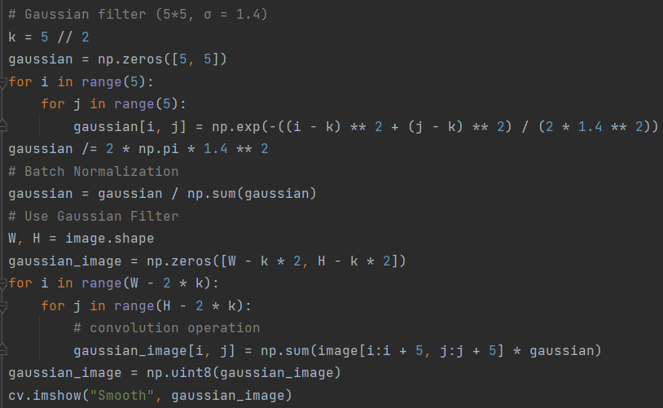

STEP2: Calculate gradient strength and direction.

Look for the edge, that is, the location where the intensity of the gray changes the most (a black edge and a white edge in the middle is the edge, which has the largest change in gray value). In the image, the gradient is used to represent the change degree and direction of the gray value.

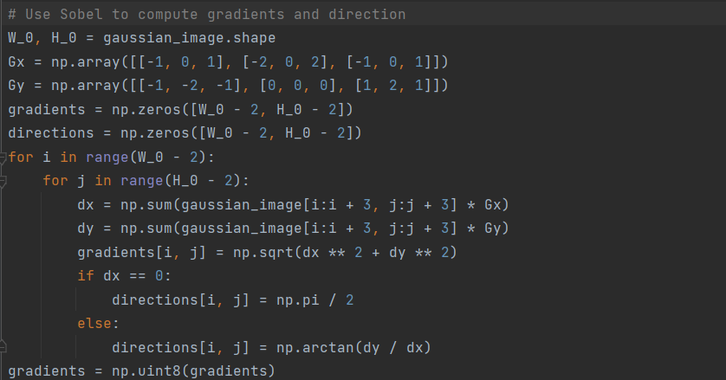

STEP3: Apply non-maximum suppression technique NMS to eliminate edge false detection.

The aim is to make a blurred border sharp. In popular terms, the maximum value of the gradient intensity on each pixel is retained, and the other values are deleted.

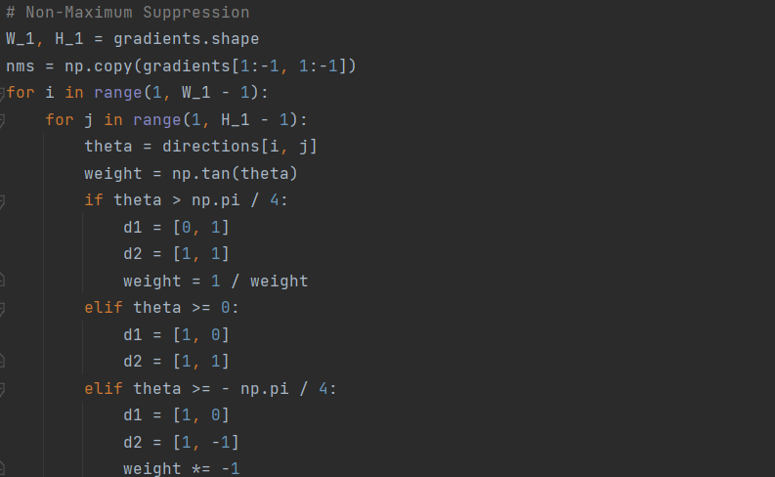

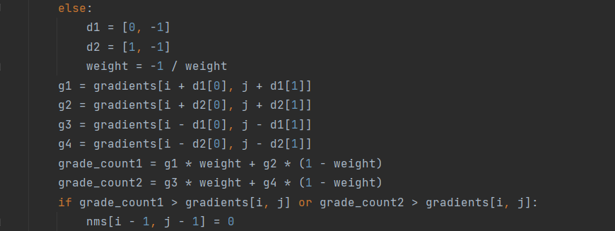

STEP4: Apply the method of double threshold to determine possible boundaries.

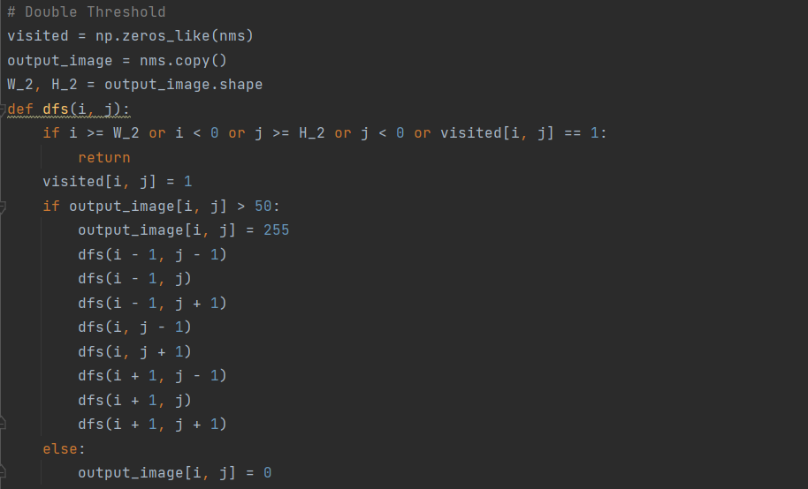

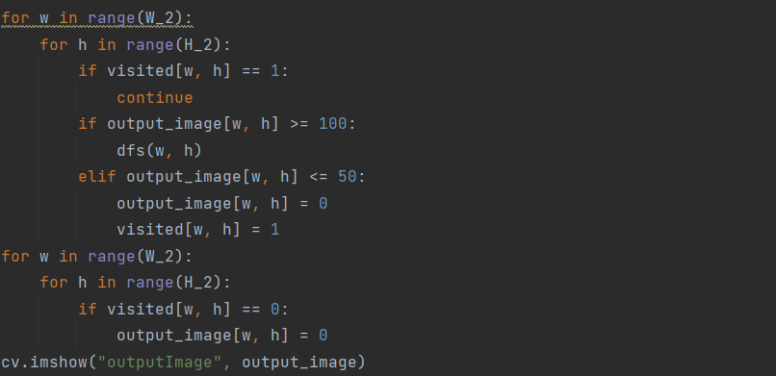

STEP5: Apply Harris Corner Detector to identify features.

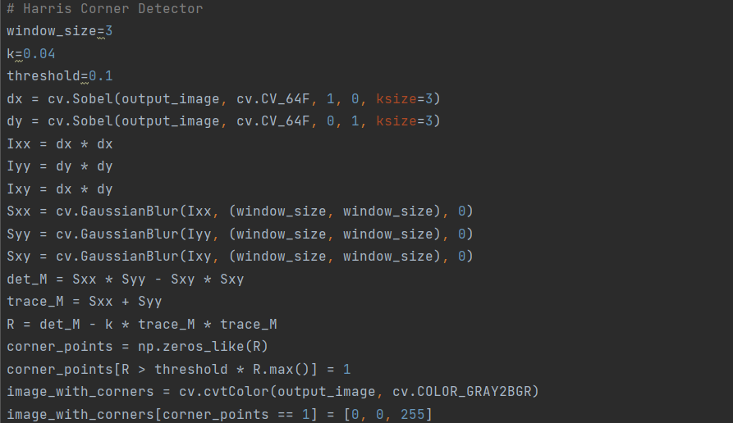

Results of Implement:

Original image:

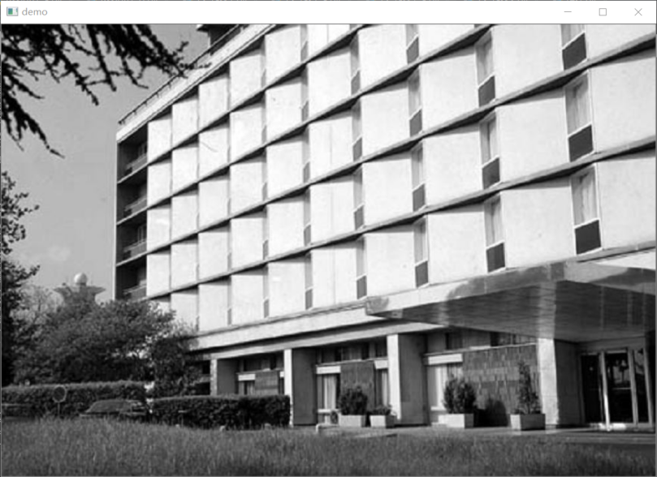

Smoothed image:

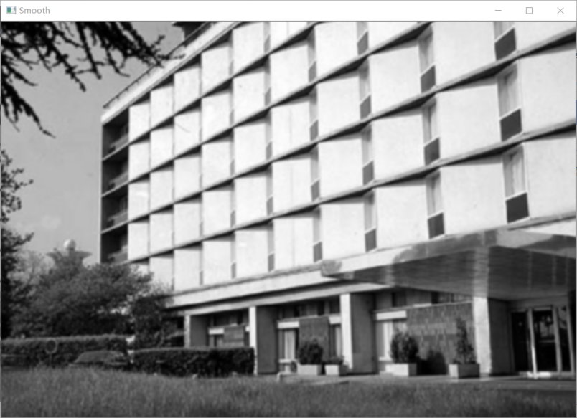

Edge detected image:

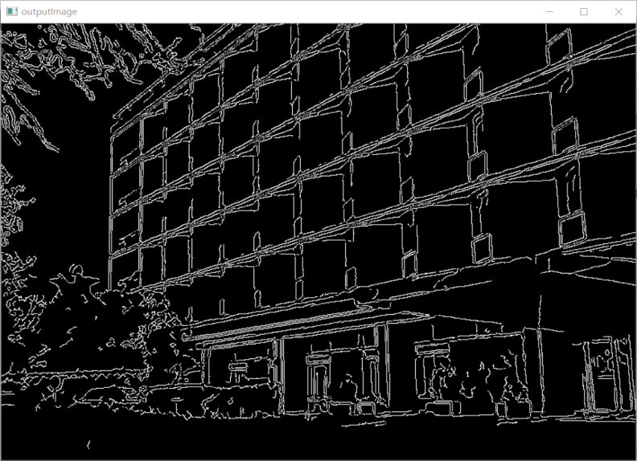

Corner detected image:

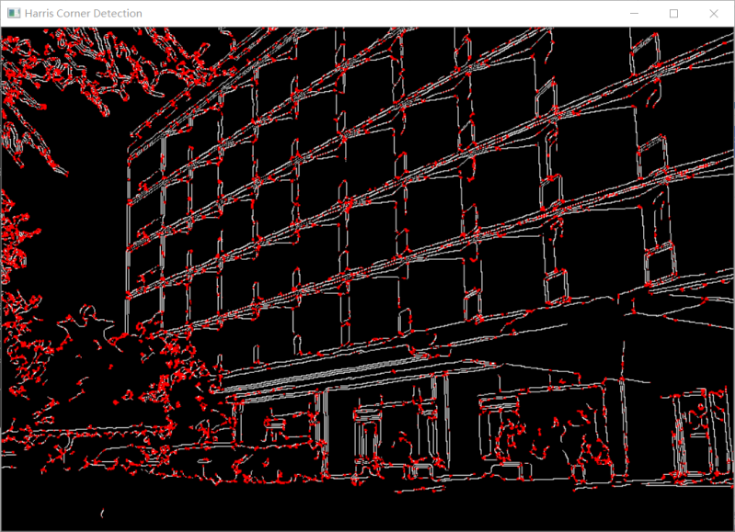

**TASK2**

STEP1: Read in the images and change them to grayscale images.

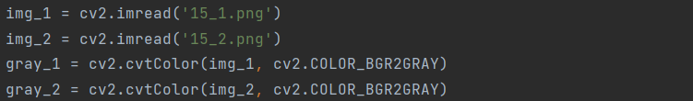

STEP2: Build SIFT or SURF objects, then detect and compute the key points and descriptor.

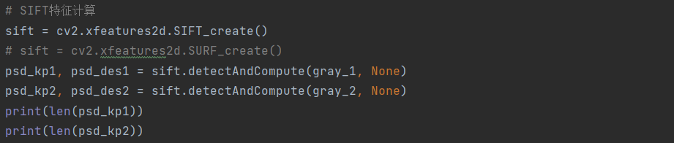

STEP3: Use FLANN to match the key points and draw them out on the images.

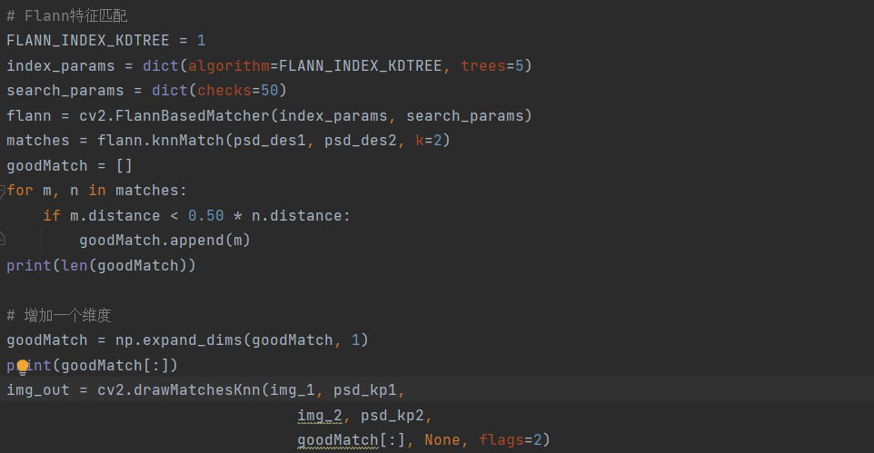

Results of Implement:

SIFT:

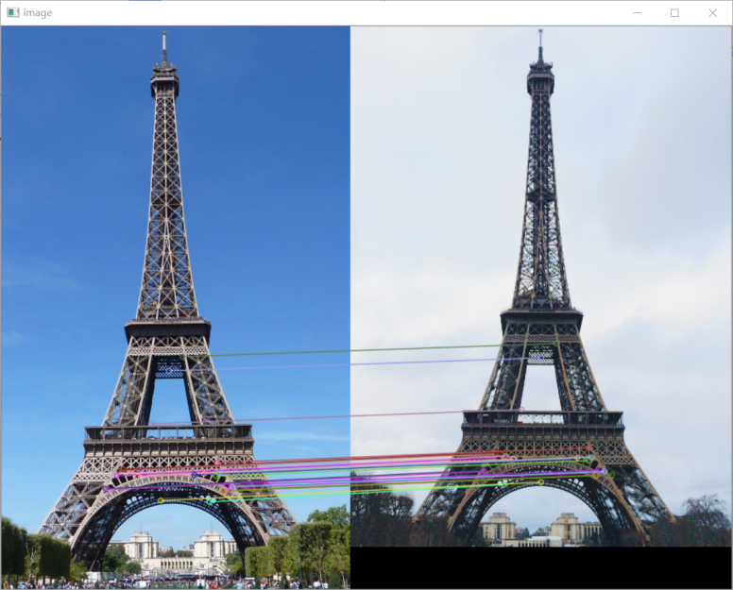

SURF:

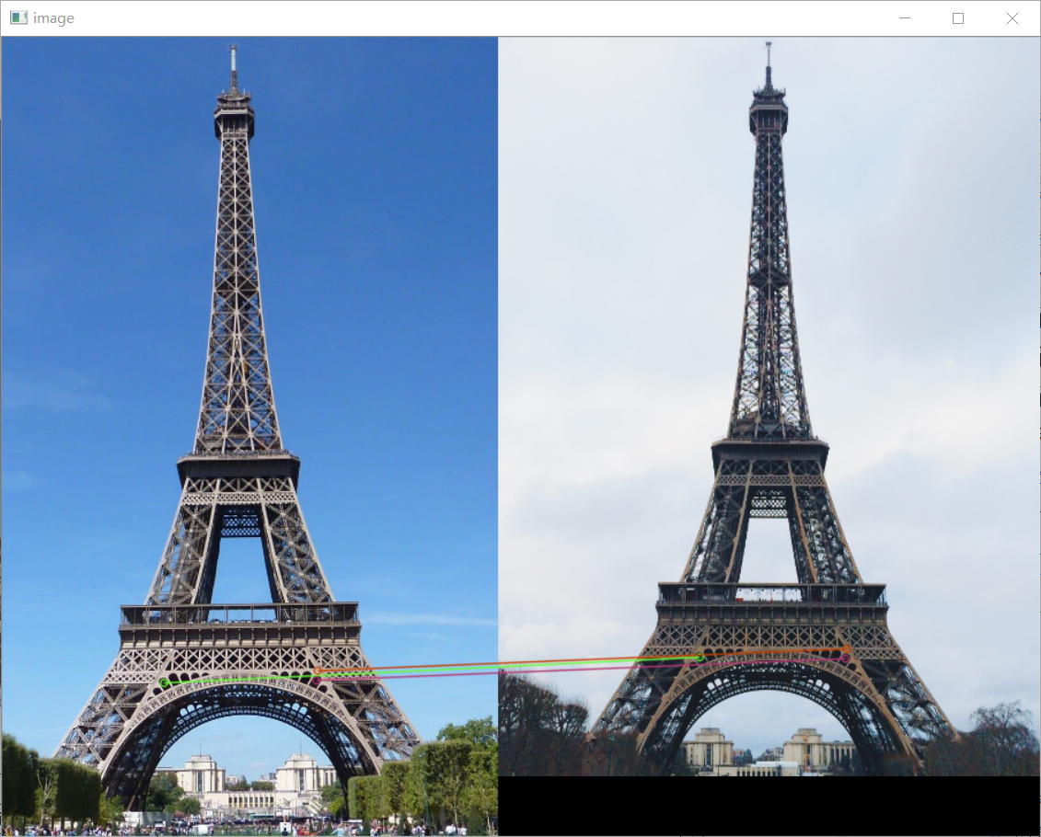

|  |  |  |
| --- | --- | --- |
|  | SIFT | SURF |
| Time cost | 0.13660812377929688 s | 0.3820044994354248 s |
| Total key points (small amount) | 1385 | 1573 |
| Matched key points | 26 | 3 |
| The percentage of matches | 1.88% | 0.191% |

SIFT:

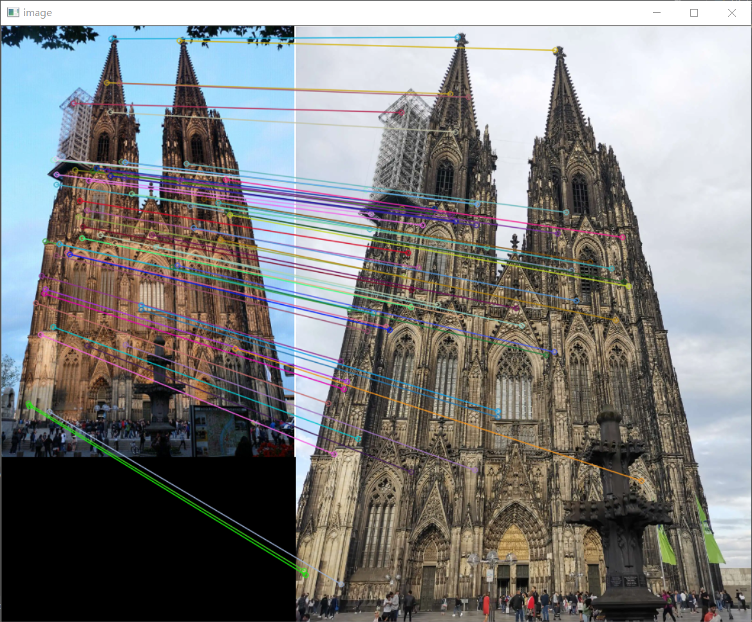

SURF:

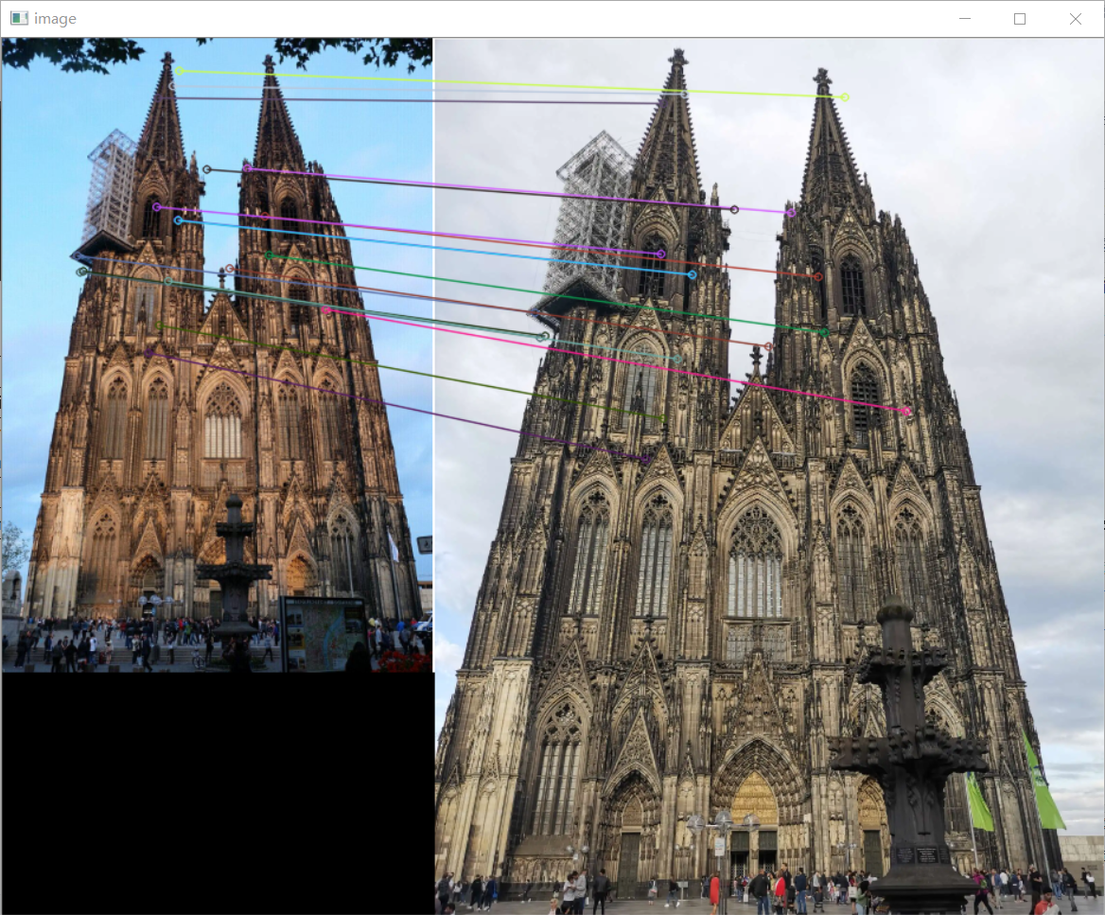

|  |  |  |
| --- | --- | --- |
|  | SIFT | SURF |
| Time cost | 0.2161414623260498 s | 0.4819209575653076 s |
| Total key points (small amount) | 2493 | 2371 |
| Matched key points | 62 | 18 |
| The percentage of matches | 2.49% | 0.759% |

SIFT:

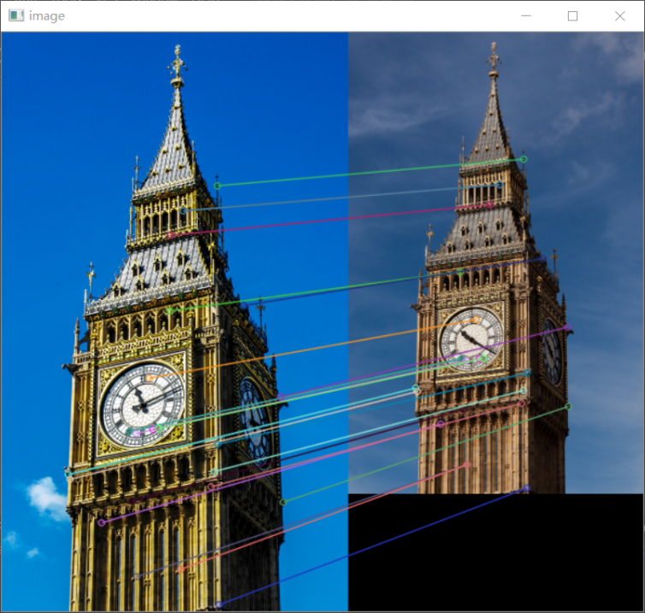

SURF:

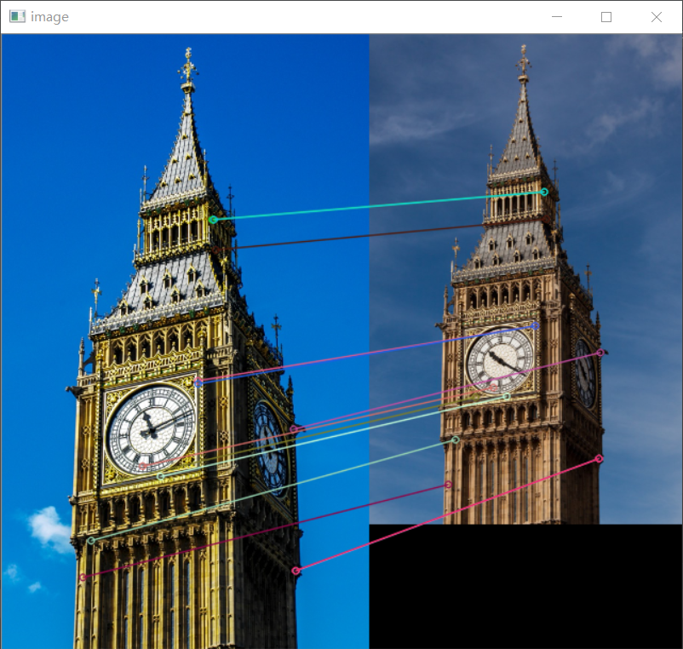

|  |  |  |
| --- | --- | --- |
|  | SIFT | SURF |
| Time cost | 0.08487749099731445 s | 0.36838197708129883 s |
| Total key points (small amount) | 738 | 1018 |
| Matched key points | 25 | 13 |
| The percentage of matches | 3.39% | 1.28% |

SIFT:

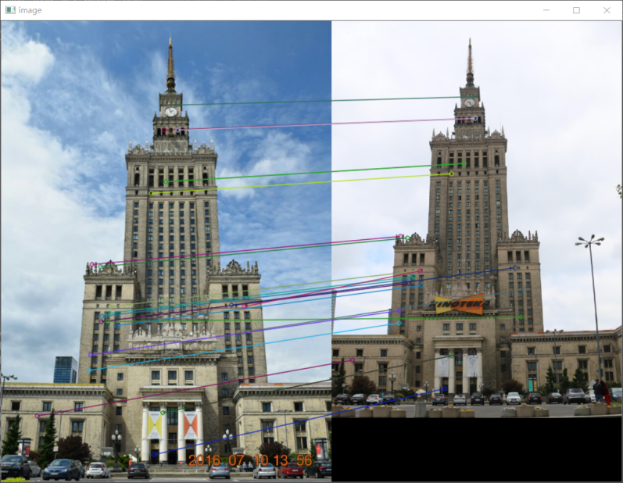

SURF:

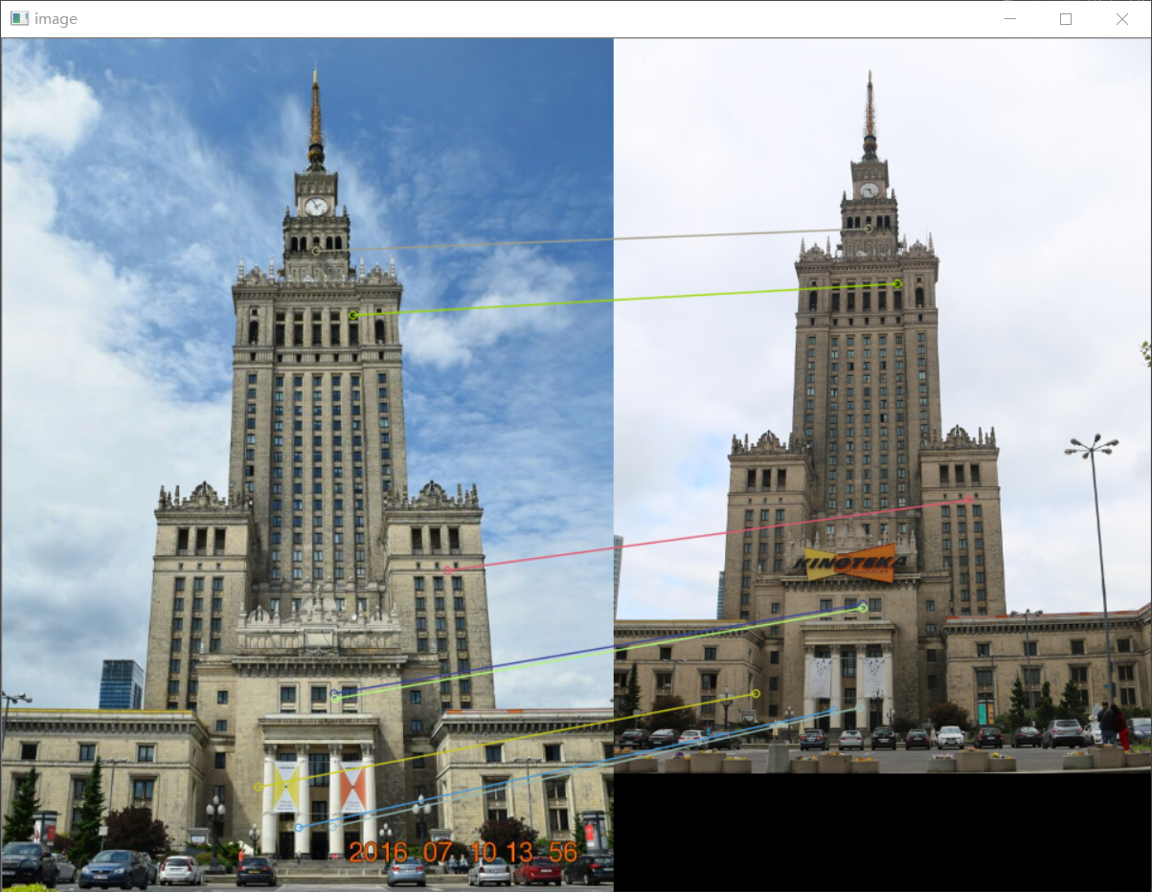

|  |  |  |
| --- | --- | --- |
|  | SIFT | SURF |
| Time cost | 0.16718769073486328 s | 0.53013014793396 s |
| Total key points (small amount) | 1594 | 2054 |
| Matched key points | 23 | 8 |
| The percentage of matches | 1.44% | 0.389% |

SIFT:

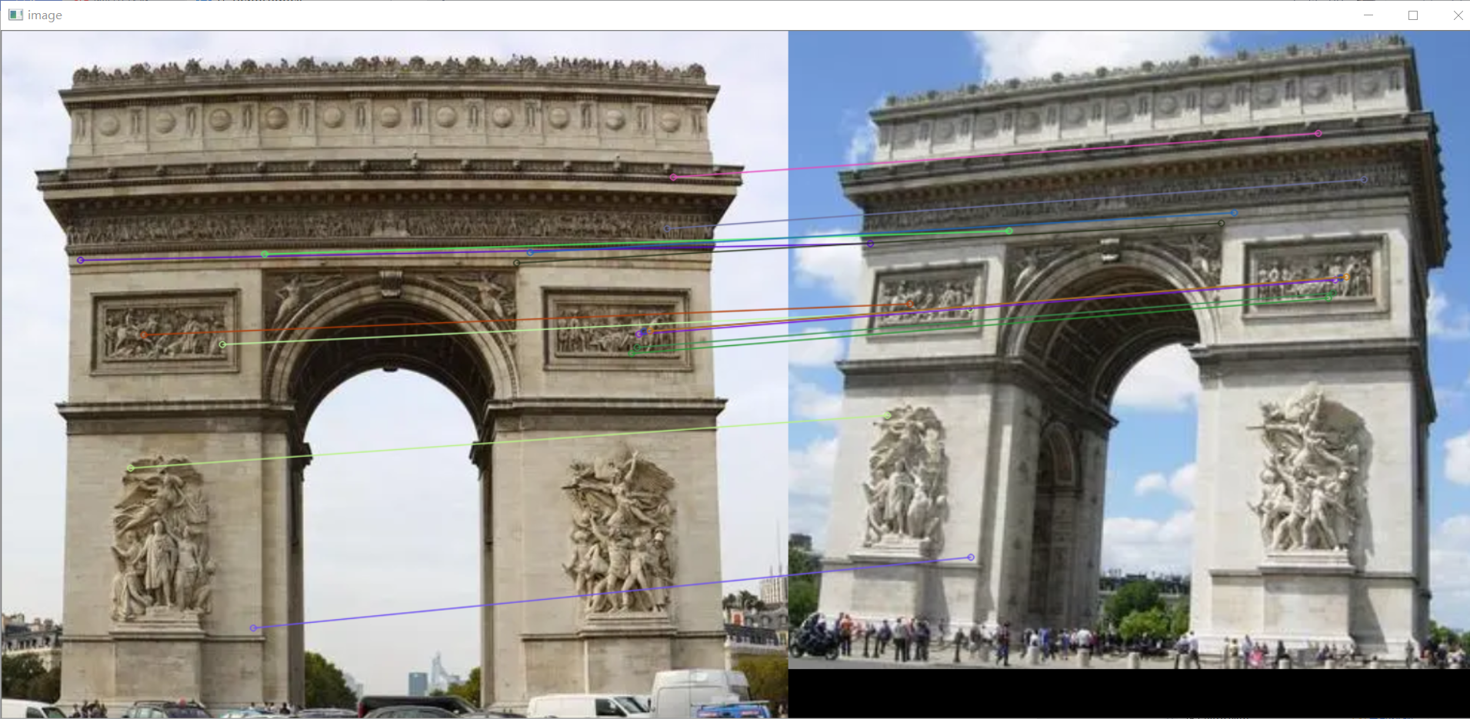

SURF:

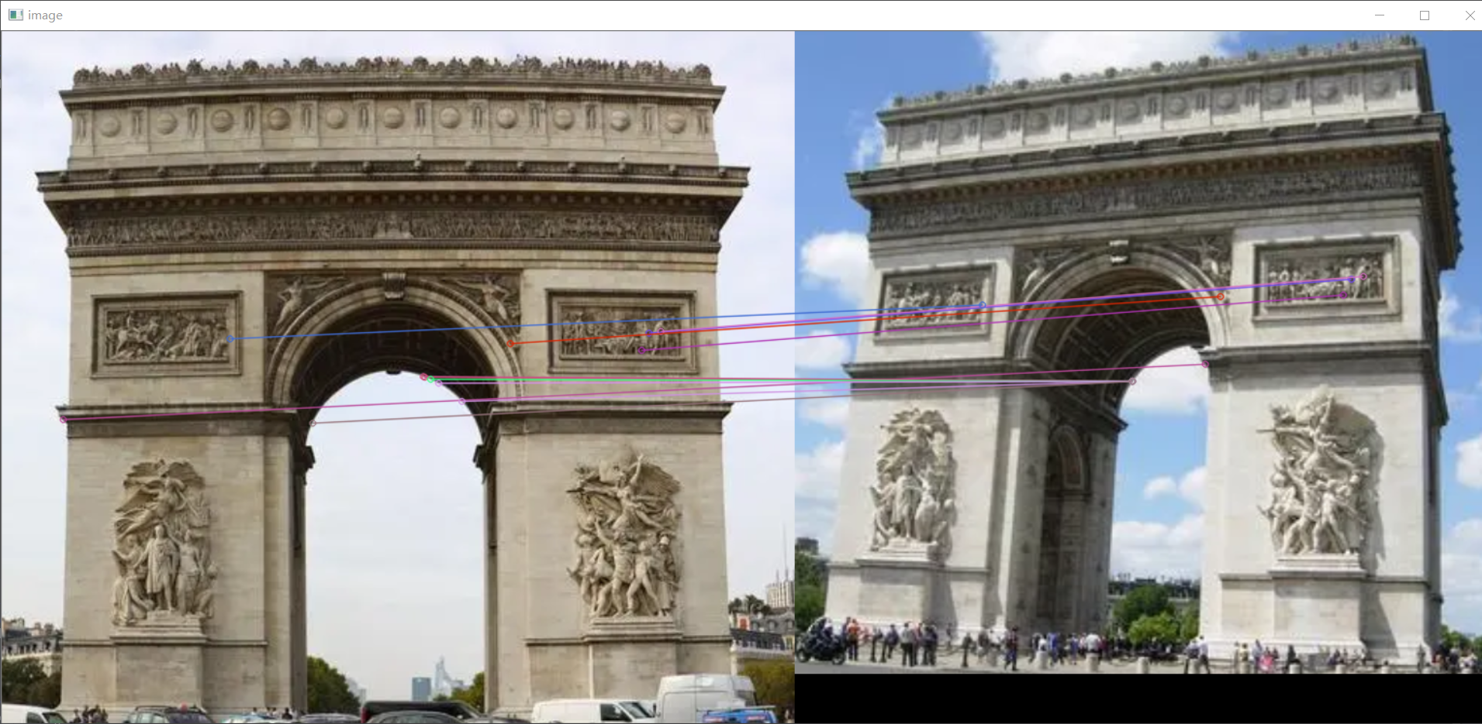

|  |  |  |
| --- | --- | --- |
| Time cost | 0.3048267364501953 s | 0.5895392894744873 s |
| Total key points (small amount) | 3313 | 3654 |
| Matched key points | 15 | 12 |
| The percentage of matches | 0.453% | 0.328% |

**Conclusion**

From the tables, I can find that SIFT always has batter performance in terms of time. SIFT also has batter percentages of matches. However, for the most time, SURF algorithm can detect more key points.